Practical 3
Aim:
1. Implement a GRE Tunnel
2. Implement VTP
3. Implement NAT
1. Implement a GRE Tunnel:
What is GRE Tunnelling?
Generic Routing Encapsulation, or GRE, is a protocol for encapsulating data packets that use one routing protocol inside the packets of another protocol. "Encapsulating" means wrapping one data packet within another data packet, like putting a box inside another box. GRE is one way to set up a direct point-to-point connection across a network, for the purpose of simplifying
connections between separate networks. It works with a variety of network layer protocols. Encapsulating packets within other packets is called "tunnelling." GRE tunnels are usually configured between two routers, with each router acting like one end of the tunnel. The routers are set up to send and receive GRE packets directly to each other. Any routers in between those two routers will not open the encapsulated packets; they only reference the headers surrounding the encapsulated packets in order to forward them.
Step 1: Design the Topology.
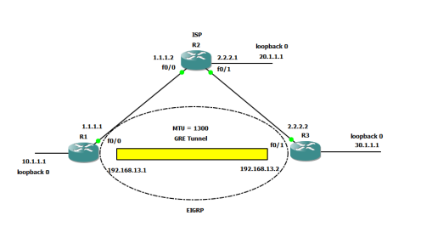
Step 2: Configure the System.
• R1:
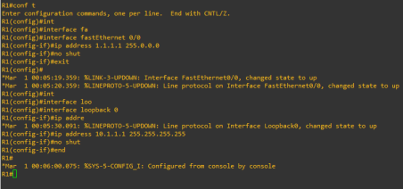• R2:
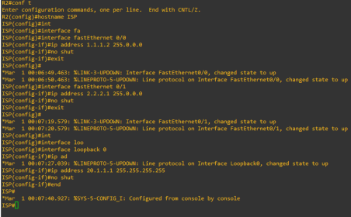
• R3:
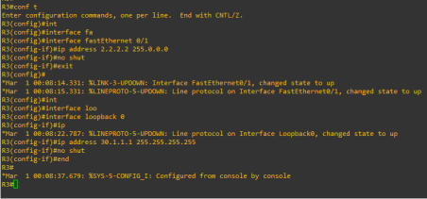
Step 3: Check the connection between R1, ISP, R3.
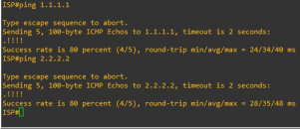
Step 4: Create the GRE Tunnel.
• R1:
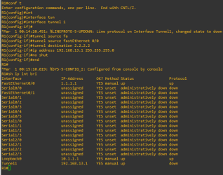
• R3:
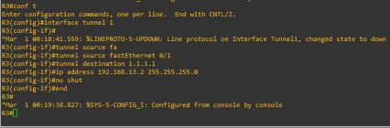
Step 5: Assign a Static Route for R1 & R3.
• R1:
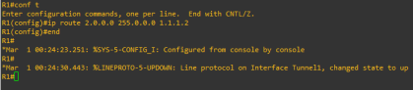
• R3:
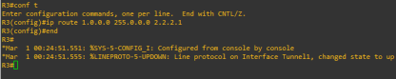
Step 6: Check whether the tunnel works.
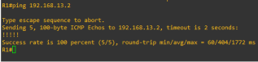
Step 7: Configure EIGRP for R1 & R3.
• R1:
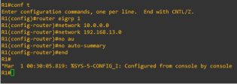
• R3:
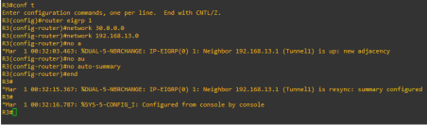
Step 8: Check whether EIGRP is configured for R1 & R3.
• R1:
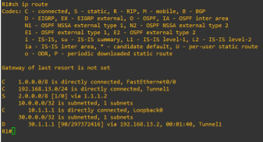
• R2:
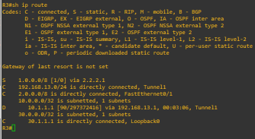
Step 9: To set MTU as the GRE Head.
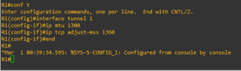
2. Implement NAT:
What is NAT?
Network Address Translation (NAT) is a process in which one or more local IP address is translated into one or more Global IP address and vice versa in order to provide Internet access to the local hosts. Also, it does the translation of port numbers i.e. masks the port number of the host with another port number, in the packet that will be routed to the destination. It then makes the corresponding entries of IP address and port number in the NAT table. NAT generally operates on a router or firewall.
Step 1: Design the Topology. Use c7200 Router IOS
Step 2: Configure the network.
• R1(gateway):
• R2(ISP):
• PC1:
• PC2:
Step 3: Create a Static Route.
Step 4: Create a Default Route.
Step 5: Make a pool of IP Address which can be used as Public IP Address: Run the command: ip nat pool public-access 199.99.9.32 199.99.9.35 netmask 255.255.255.252
Step 6: Make an access list that will map the public IP addresses to the inside private IP addresses and define the NAT translation from inside list to outside pool.
Step 7: Now we will define which interface is inside and which one is outside.
Step 8: Now ping from the PC to the loopback of ISP.
PC1:
PC2:
Step 9: Verify NAT & PAT Translations.
Step 10: Verify NAT & PAT Statistics.
Implement VTP
Objective
• Create the following VLANS on switch Bobcat:
• VLAN 10: name Tigers
• VLAN 20: name Lions
• VLAN 30: name Panthers
• Configure the interfaces between the switches as trunks.
• Configure switch Bobcat to be the VTP server.
• Configure switch Panther to be a VTP client.
• Configure switch Tiger so it does not synchronise itself to the lastest VTP information, it should forward advertisements to switch Panther though.
• Change the VTP domain name to “MSCCS”.
• Use the password “MSCCS123” for VTP.
• Make sure there is no unnecessary vlan traffic flooded on the trunk links.
• Create the following VLANS on switch Bobcat:
VLAN 10: name Tigers
VLAN 20: name Lions
VLAN 30: name Panthers
• Configure the interfaces between the switches as trunks.
• Configure switch Bobcat to be the VTP server.
• Configure switch Panther to be a VTP client.
• Configure switch Tiger so it does not synchronise itself to the lastest VTP information, it should forward advertisements to switch Panther though.
• Change the VTP domain name to “MSCCS”.
• Use the password “MSCCS123” for VTP.
• Check and verify the VLANs
• Make sure there is no unnecessary vlan traffic flooded on the trunk links.

